**Install a Windows 10 VM in VMware Workstation 16**

Written by David Buck, May 2021

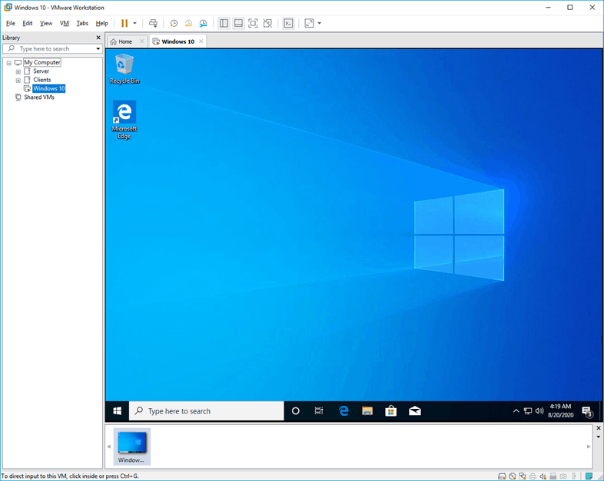

To test something or learn new skills in an IT environment it is often better to use a virtual machine or VM running inside a hypervisor such as vmWorkstation. The VM can be used to experiment with and if you break something with the VM configuration, you can still recover the previous state of the virtual machine if you use snapshots.

The advantage of this is since the VM environment and the physical host environment is separate, whatever you do on the VM environment stays at the VM environment. This practical worksheet lists how to install Windows 10 on our hypervisor, our VMware Workstation 16 installation. We will also install the VMware tools at the end to get improved performance and more functionality, such as copying across files, with the virtual machine. Finally, we will update the VM via Windows Update.

**The steps to install windows 10 on VMware Workstation 16:**

Meet the Prerequisites.

1. Create New virtual machine.

2. Choose Custom option.

3. Choose the hardware compatibility.

4. Attach the Windows ISO file.

5. Select the operating system.

6. Select the Firmware Type.

7. Configure the system CPU and Memory.

8. Setup the network interface.

9. Select the I/O controller.

10. Setup the virtual Hard disk.

11. Verify the configuration.

12. Start the Windows installation.

13. Install VMware Tools on Windows machine.

Updating your Windows 10 VM

Disclaimer: This guide is for Windows 10 and vmWorkstation 16 was created in May 2021. The settings for virtual machines and vmWorkstation may change in the future in TAFE courses. Students are required to be aware of the current technical specifications and assessment requirements for virtual machines using the vmWorkstation hypervisor.

**Meet the prerequisites.**

**Before you proceed there are two prerequisites for this installation:**

* A Windows 10 bootable ISO.
* And VMware Workstation 16.

Students will be instructed in how to locate both files on the network storage location. Students will need to ensure that they understand and manage the locations of the VM’s and Iso’s on their external drives.

Note that the VMware workstation hypervisor is pre-installed on the classroom PC’s, and students are downloading this file to setup the hypervisor on their home Pc’s if they are suitable.

Go to the location you want to store your VM in file explorer and create a new folder for this VM. This location should be on your new large external drive if you have a new USB3 version of this drive. Give the new folder a meaningful name such the type of operating system, the week it was installed and your initials. For example, Win10Week1DB

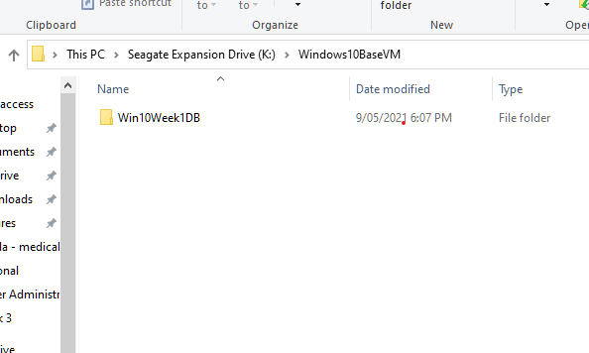

The lecturer will specify the download location of the ISO file used to create the new VM, then go ahead and download the file right now. Students cannot run the ISO file across the network as the installation will time out. Students can create a separate ISO folder to locate the various ISO files as they start using these files in this course.

**1. Create New virtual machine.**

Start the VMware workstation program and click on **Create a new virtual machine.** This will start the new virtual machine wizard.

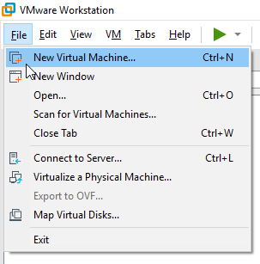

**2. Choose Custom option.**

There can be issues if you choose the default option Typical, the windows machine may not load properly during the boot process, so to avoid that we recommend that students choose **Custom (advanced)** and click on **Next**.

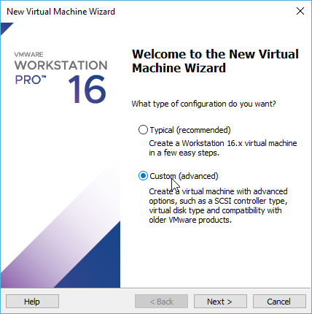

**3. Choose the hardware compatibility.**

Since I am using version 16, I would choose Workstation 16.x. as the Hardware compatibility.

As you can see VMware workstation 16 supports increased hardware features.

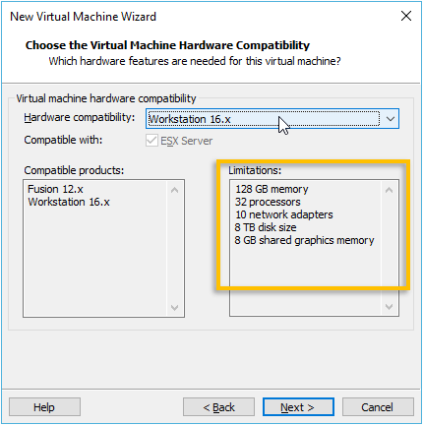

Just for comparison, review VMware workstation 15 hardware compatibility listed below.

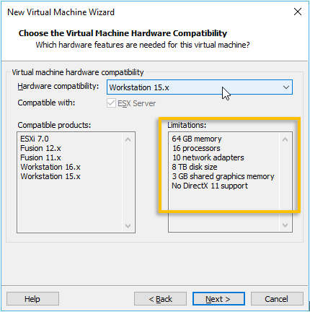

NOTE - We are choosing VMware workstation 16 compatibility.

**4. Attach the Windows ISO file.**

We have already downloaded the Windows ISO file and you need to attach this file now.

You can attach the Windows 10 ISO that you have downloaded earlier by clicking on Browse.

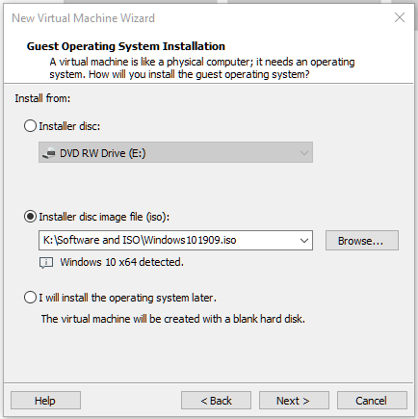

**5. Select the operating system.**

By default, it should pick up windows10, if not you may manually select this.

If you get an optional prompt for the Guest operating system, choose**Microsoft windows and the version is windows 10.**

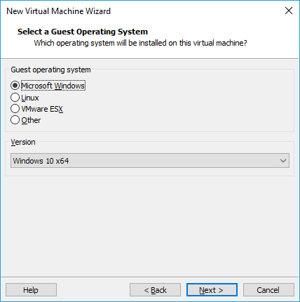

Name the virtual machine name and use the location you created earlier where you want to install the new operating system, you may click on Browse if you would like to change the location. It is recommended that students create a BaseVM folder that can be used to create and copy VMs between courses, thereby maximising the student work rate.

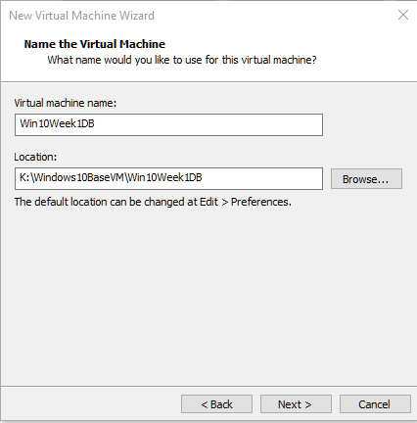

**6. Select the Firmware Type.**

Select the firmware type as **UEFI**and click on **Next**.

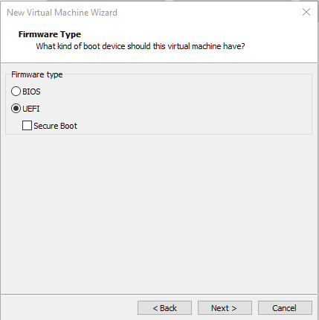

**7. Configure the system CPU and Memory.**

Next, we configure the **Processor Configuration** for the system,and we accept the default value of 1 processor and 2 cores per processor and then click on **Next.**

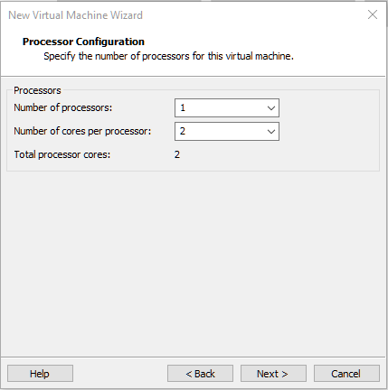

For **Memory for the Virtual Machine**, we also accept the default setting of 2048Mb and then click on **Next.**

Note that this setting can be changed later if required.

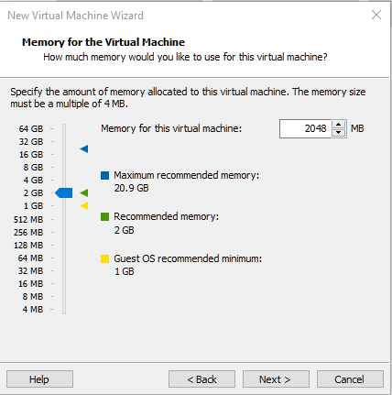

**8. Setup the network interface.**

We want our Windows VM to first be able to access the internet, and to access the internet we must use the NAT interface. Choose the **NAT interface** and click on **Next.**

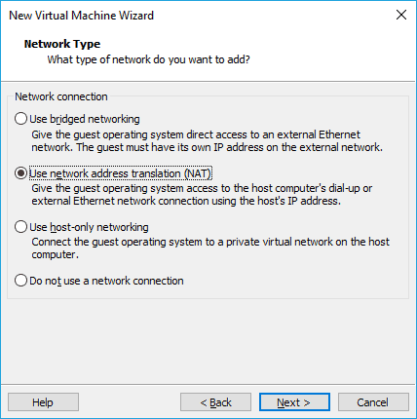

**9. Select the I/O controller.**

In the I/O controller, Types select the recommended option in this case **LSI Logic SAS.** Which is the default option, click on **Next.**

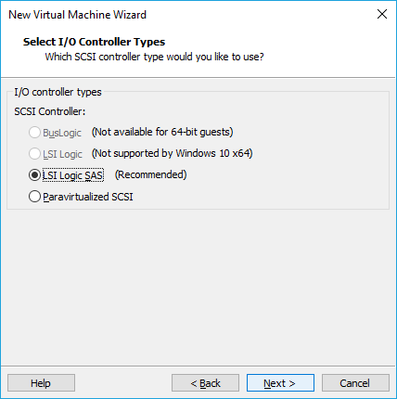

**10. Setup the virtual Hard disk.**

We are now going to setup the virtual hard disk for the Windows machine. Choose NVMe as the Disk type and click on **Next.**

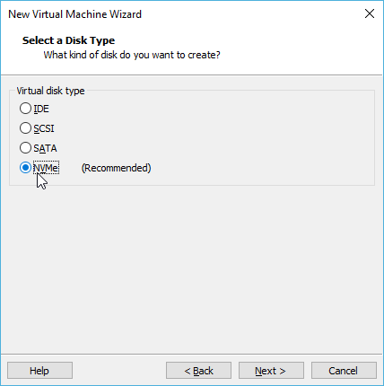

Choose Create a new virtual disk and click on **Next**.

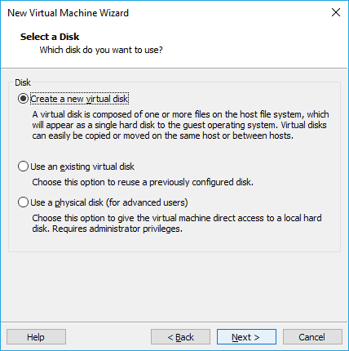

We now need to configure the storage capacity for the machine, by default it would **pick up the storage as 60GB**. We recommend that you change the default option, otherwise if you create too many VM’s at this storage amount the student will quickly run out of space on their large external drive.

Also choose the option, **Store virtual disk as single file.** This makes the virtual machine easier to move and manage for students new to virtualisation.

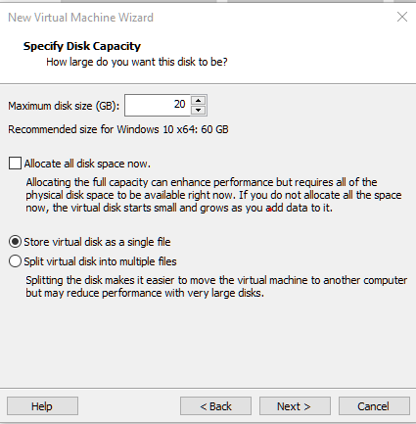

For the virtual hard disk that we have created, you can change the name now. I am setting the name of the hard drive to the same as the “meaningful” virtual machine name and leaving in the same location, then I will click on **Next.**

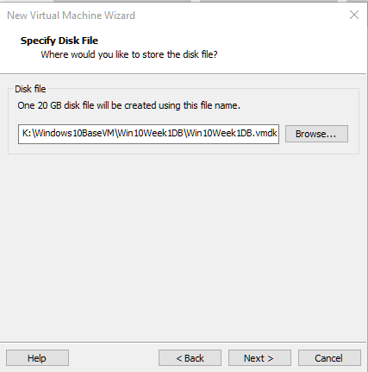

Students should ensure that they correctly locate the components of their VM’s to avoid an “orphaned VM” that is missing key components. This correct location of components directly relates to industry expectations and best practice for using virtual machines.

Organisations can experience considerable inconvenience relating to VM’s that have hours of work invested in them being lost or broken due to location or documentation issues.



**11. Verify the configuration.**

Here you can see the properties of the VM that we are going to deploy, verify the configuration “created with the following settings:”. If you found a part of the configuration that is not correct you may click on **Customize Hardware** and modify it. I am not changing anything after viewing the settings, so I clicked on **Finish**.

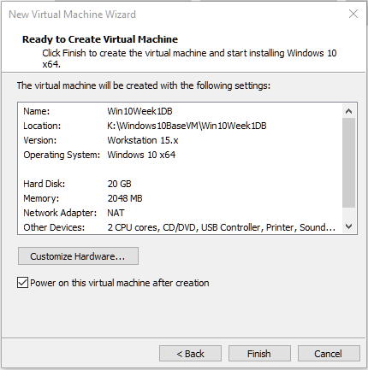

**12. Start the windows installation.**

It will take few seconds for the virtual hard disk to create. After the Hard disk creation, the student now should be able to see the Windows 10 virtual machine has been created and it will now power on, because you already checked the option “Power on this virtual machine” after the previous step.

**Select CD/DVD to continue**. On the windows installation menu, select time and currency format as **English (Australia),** then click on **Next**.

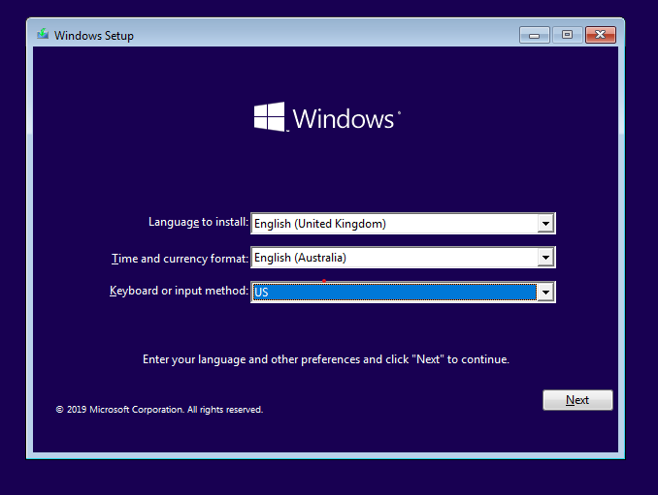

The windows installation screen appears now, click on **Install Now** button.

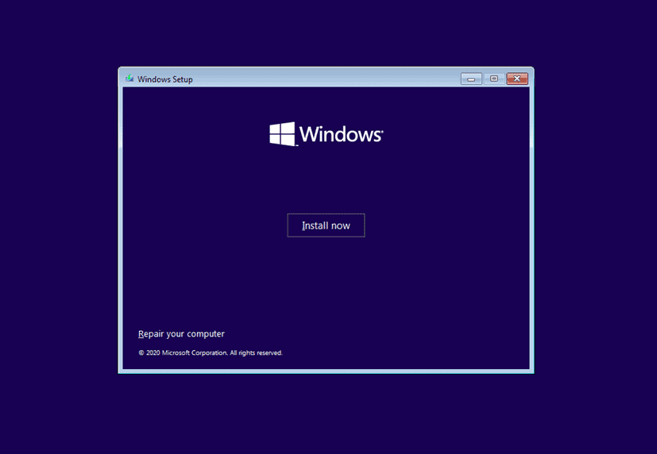

If you have a product key, you may enter it now here, else click on I don’t have product key, option and click on **Next**.

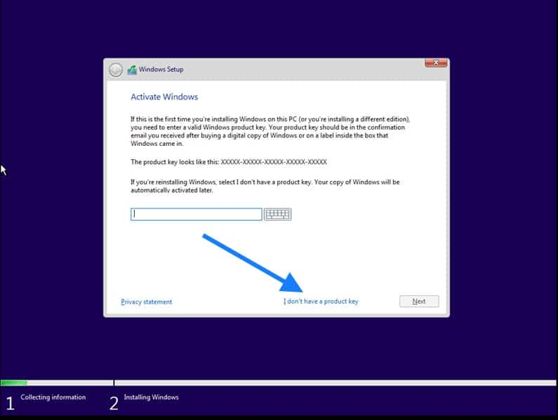

Choose the version of windows that you wanted to install, I am choosing Windows 10 pro and click on next.

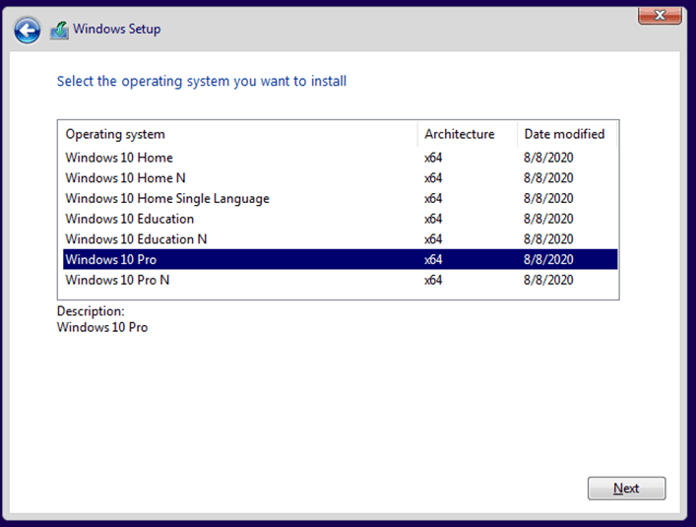

Accept the license agreement and click on Next.

Note: Students are only to licence their Windows 10 virtual machines if instructed by their lecturer.

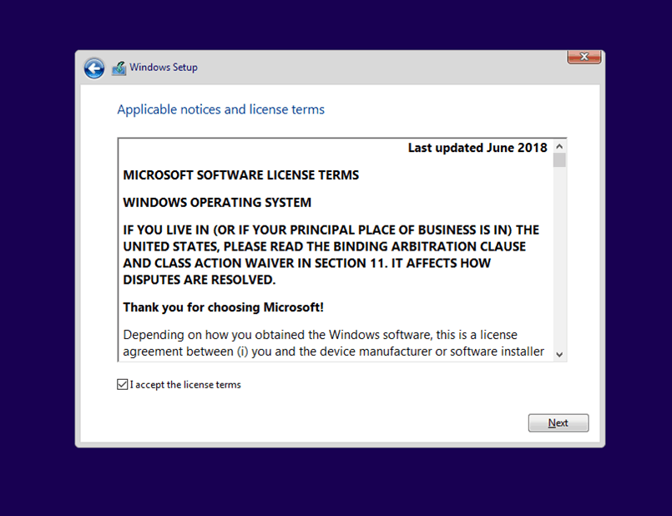

In the type of installation click on Custom.

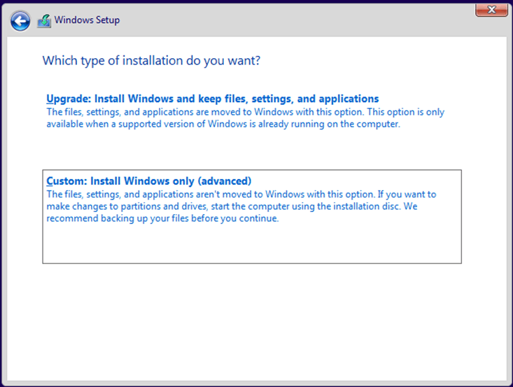

You will now be presented with the virtual hard disk storage that you have defined earlier. Click the Drive and click **Next**.

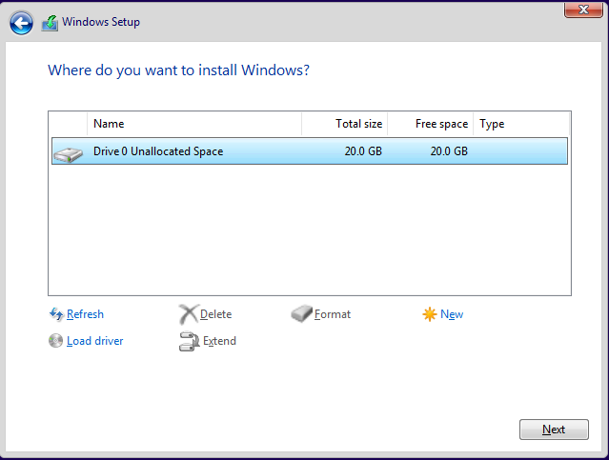

The installation of windows now begins, and you will be able to see the progress.

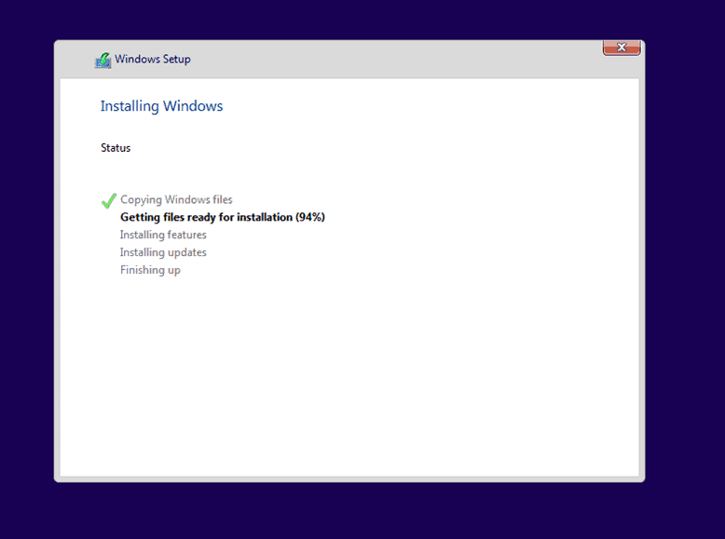

After the initial setup, you now have Windows 10 Pro installed on the VMware workstation pro.

The setup process after installation will allow you to specify keyboard settings, an additional keyboard if you need one, I just selected **Next**, as well to set the defaults for the operating system. When setting up the network, specify “Set up for an organisation”, then select **Next**.

The screen offering to “Sign in with Microsoft” appears but ensure that you select the bottom left of the screen for **Domain join instead**.

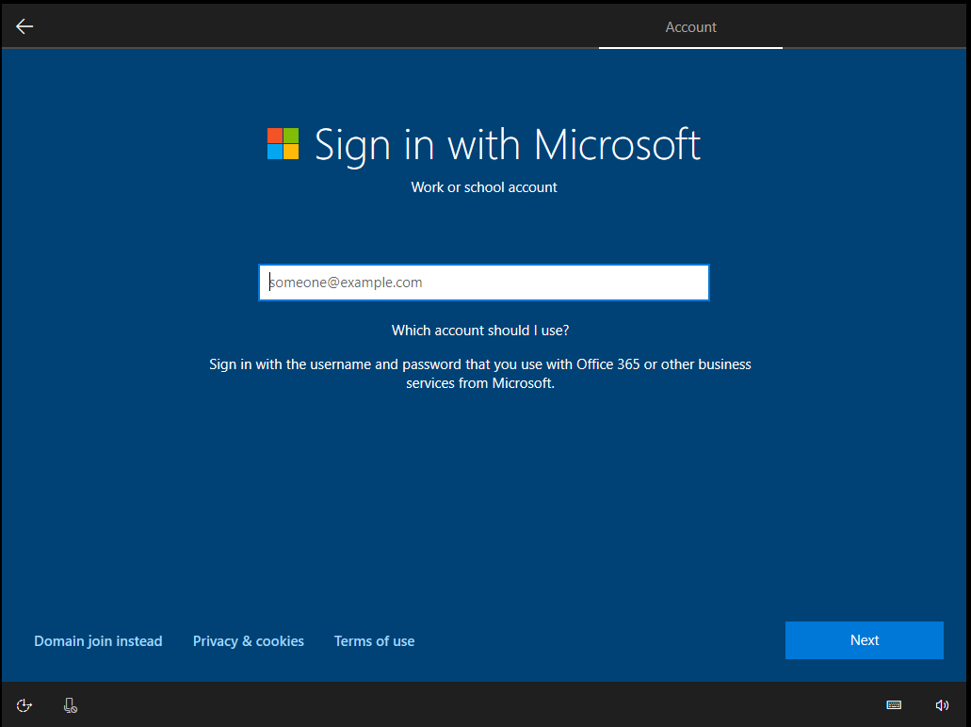

When you are prompted by “Who’s going to use this PC?” – enter in your first name, then a password – P@ssw0rd is used as the default in class – twice. Answer the three security questions with your own answers, answering No or Decline for the next pages, before selecting Accept for the default privacy settings.

The PC now is finishing off the installation over the next several minutes.

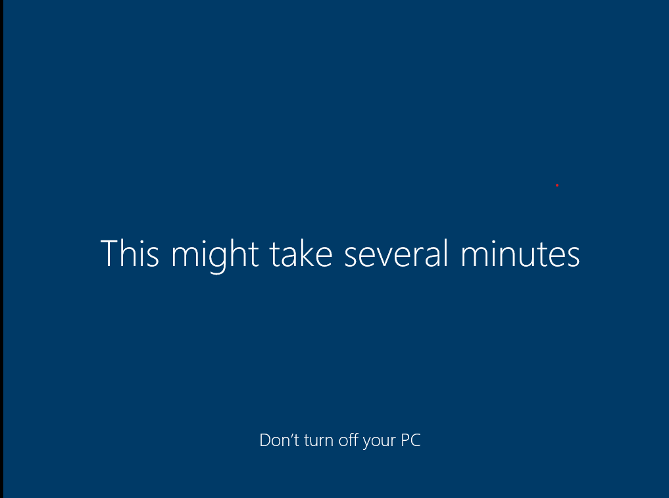

You can now click on “I finished installing” on the bottom of the vmWare Workstation screen if this prompt appears.



**13.** **Install VMware tools on windows machine.**

We have now successfully installed the windows 10 operating system on VMware workstation pro. However, to get good performance you will have to also install the VMware tools on the machine.

Click on VM and choose the option that says Install VMware tools..

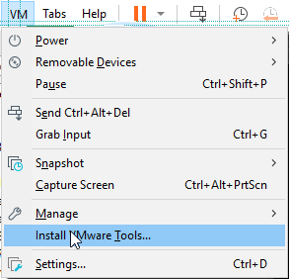

Wait for few seconds, you will get a notification on the bottom right of the screen that says **DVD Drive (D:) VMware Tools.** Click on the notification.

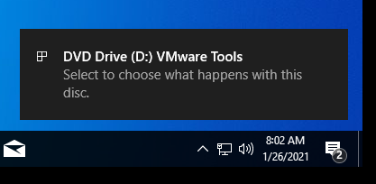

That should open up the prompt, choose Run setup64.exe, this is the VMware tools software package.

If the prompt does not appear you can navigate to D: drive via File Explorer and select the VMware Tools manually to access setup64.exe.

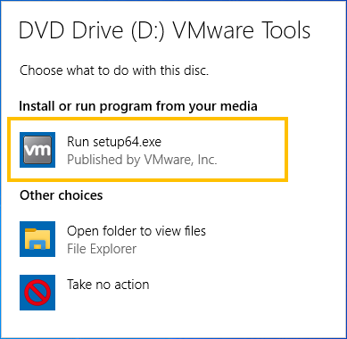

The VMware tools installation now will begin, you can click on **Next** here.

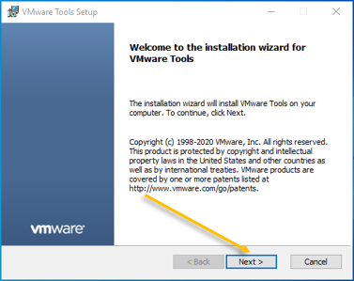

On the next screen choose Typical and click on **Next**.

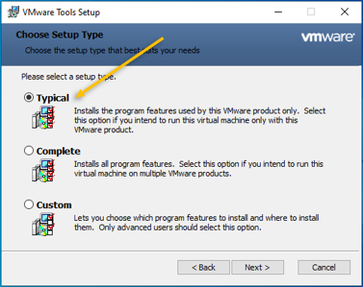

After few seconds, the VMware tools will be installed on the windows machine. You will also notice the display resolution gets adjusted according to the VMware workstation windows size, this is a useful feature. Also, you now can copy/paste files between your host computer and the new VM.

You may click on **Finish**and you are required to restart the machine to complete the VMware tools installation.

**Updating your Windows 10 VM**

Windows operating systems require frequent updates, and providing you have enough time in this class session, you can manually trigger a Windows Update.

Select the Looking glass symbol or Search symbol in the bottom left screen for the Windows 10 VM and type **Windows Update**.

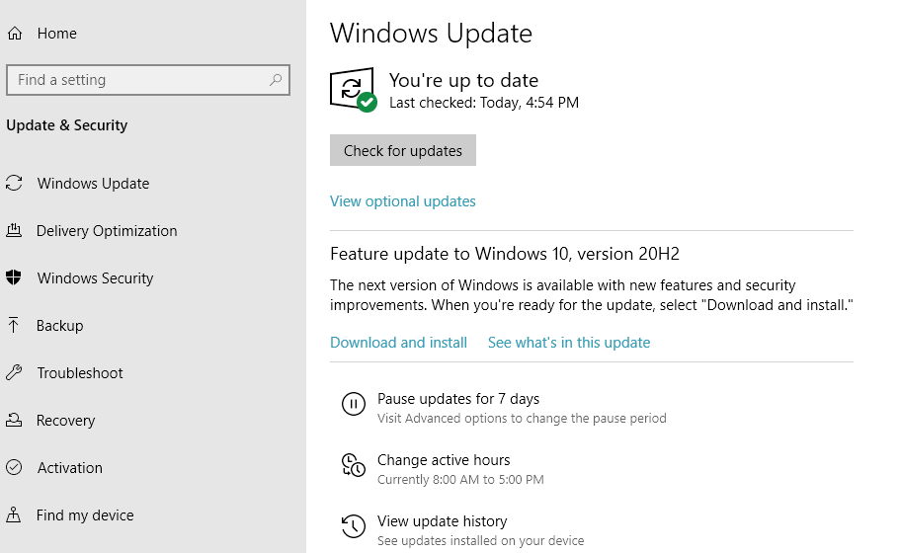

You can then select **Check for Updates** and the operating system will give you the option to install updates as they are located.